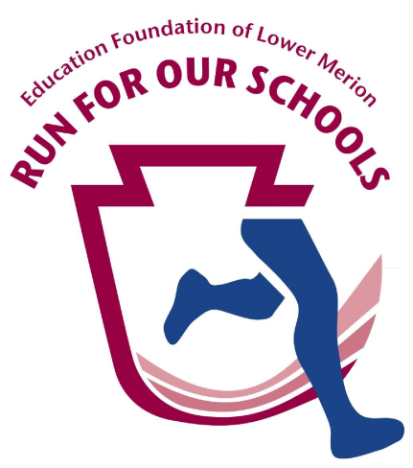
Education Foundation of Lower Merion
“Run For Our Schools” 5K Run/Walk

www.lowermerionrun.org

Sunday, June 5, 2016, 9:00 a.m.

Harriton High School
600 N. Ithan Avenue, Rosemont PA 19010

Eighth Annual “Run For Our Schools”
Sponsorship Form

Category | Contribution | Recognition
Lead Sponsor | $ 1,000 | - Business logo/name on race application/website  - Premium placement of large name/logo on shirts  - 6 complimentary race entries  - Business cards, coupons, and giveaways included in race packets
Gold | $ 500 | - Large logo/name listed on back of shirts  - 4 complimentary race entries  - Business cards, coupons, and giveaways included in race packets
Silver | $ 250 | - Name listed on back of shirt  - 2 complimentary race entries
Bronze | $ 100 | - 1 complimentary race entry

Sponsorship Form

Business Name: _______________________________________________________

Contact Name: ___________________________ Title: ________________________

Phone: ___________________________ Email: _____________________________

Address: _____________________________________________________________

Sponsorship Level: __ Lead __ Gold __ Silver __ Bronze

Please send form and check to: Education Foundation of Lower Merion
P.O. Box 79, Narberth, PA 19072
Note: The Education Foundation of Lower Merion is a 501(c)(3) charitable organization. Your gift may be tax-deductible.

Let us know if you would like to include materials from your business for the runner packets. Please send business logos to Sherry Wert at info@educationfoundationoflm.org by Wednesday, May 25, 2016, to be included on the Run t-shirts.

